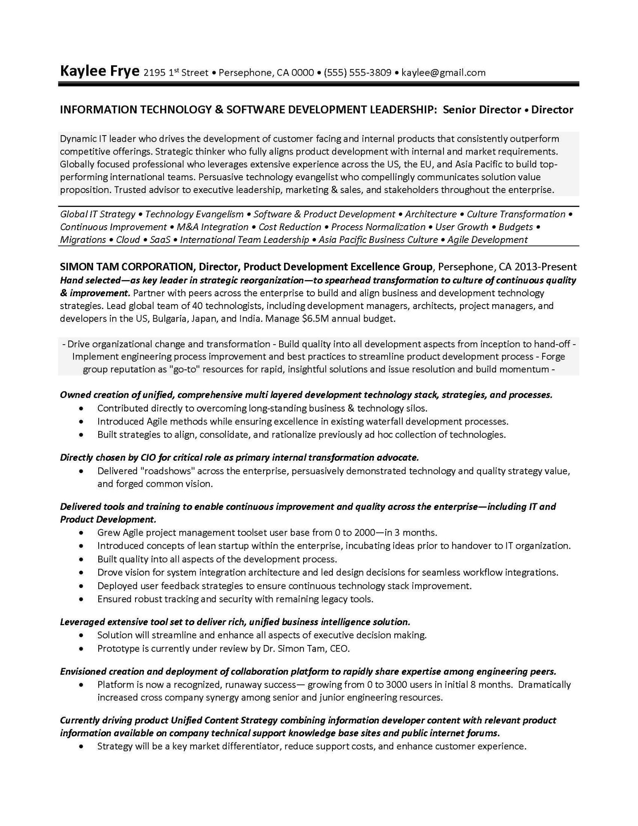
Kaylee Frye 2195 1st Street Persephone, CA 0000⚫ (555) 555-3809⚫ kaylee@gmail.com
•
INFORMATION TECHNOLOGY & SOFTWARE DEVELOPMENT LEADERSHIP: Senior Director⚫ Director
Dynamic IT leader who drives the development of customer facing and internal products that consistently outperform competitive offerings. Strategic thinker who fully aligns product development with internal and market requirements. Globally focused professional who leverages extensive experience across the US, the EU, and Asia Pacific to build top- performing international teams. Persuasive technology evangelist who compellingly communicates solution value proposition. Trusted advisor to executive leadership, marketing & sales, and stakeholders throughout the enterprise.
•
Global IT Strategy Technology Evangelism • Software & Product Development • Architecture • Culture Transformation Continuous Improvement • M&A Integration • Cost Reduction • Process Normalization • User Growth • Budgets Migrations • Cloud • SaaS • International Team Leadership • Asia Pacific Business Culture • Agile Development
SIMON TAM CORPORATION, Director, Product Development Excellence Group, Persephone, CA 2013-Present Hand selected—as key leader in strategic reorganization—to spearhead transformation to culture of continuous quality & improvement. Partner with peers across the enterprise to build and align business and development technology strategies. Lead global team of 40 technologists, including development managers, architects, project managers, and developers in the US, Bulgaria, Japan, and India. Manage $6.5M annual budget.
- Drive organizational change and transformation - Build quality into all development aspects from inception to hand-off- Implement engineering process improvement and best practices to streamline product development process - Forge group reputation as "go-to" resources for rapid, insightful solutions and issue resolution and build momentum -
Owned creation of unified, comprehensive multi layered development technology stack, strategies, and processes. Contributed directly to overcoming long-standing business & technology silos.
•
•
Introduced Agile methods while ensuring excellence in existing waterfall development processes.
Built strategies to align, consolidate, and rationalize previously ad hoc collection of technologies.
Directly chosen by CIO for critical role as primary internal transformation advocate.
•
Delivered "roadshows" across the enterprise, persuasively demonstrated technology and quality strategy value, and forged common vision.
Delivered tools and training to enable continuous improvement and quality across the enterprise-including IT and Product Development.
•
Grew Agile project management toolset user base from 0 to 2000-in 3 months.
Introduced concepts of lean startup within the enterprise, incubating ideas prior to handover to IT organization. Built quality into all aspects of the development process.
Drove vision for system integration architecture and led design decisions for seamless workflow integrations. Deployed user feedback strategies to ensure continuous technology stack improvement.
• Ensured robust tracking and security with remaining legacy tools.
Leveraged extensive tool set to deliver rich, unified business intelligence solution.
Solution will streamline and enhance all aspects of executive decision making. Prototype is currently under review by Dr. Simon Tam, CEO.
Envisioned creation and deployment of collaboration platform to rapidly share expertise among engineering peers. Platform is now a recognized, runaway success- growing from 0 to 3000 users in initial 8 months. Dramatically increased cross company synergy among senior and junior engineering resources.
Currently driving product Unified Content Strategy combining information developer content with relevant product information available on company technical support knowledge base sites and public internet forums.
• Strategy will be a key market differentiator, reduce support costs, and enhance customer experience.

